1 Corinthians Introduction
The City – Corinth
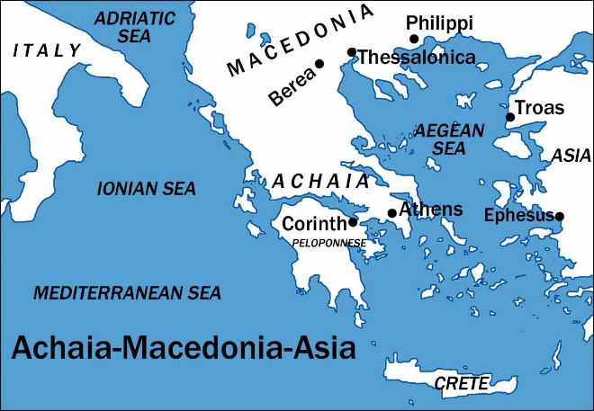
- Located on the Isthmus – narrow strip of land connecting the Peloponnesus to mainland Greece.
- Great Traffic in Corinth
  - Trade from east to west – either sail 200 miles around the cape of the peninsula, or travel across the Isthmus – about 5-6 miles.
  - Connected to mainland Greece – located on the Isthmus, people traveling from the Peloponnesus to Greece had to pass through Corinth.
- Trade Brought Wealth – this led to interest in finding ways of entertainment.
  - Isthmian Games – second only to the Olympic Games. Included racing, boxing, and other athletic events. (cf. 9:24-27)
  - Temple to Aphrodite – goddess of love. The temple housed 1,000 priestesses who acted as religious prostitutes. “Worshipers” all over were attracted to the temple. Sexual immorality was rampant (cf. 6:15-20)
  - Other Temples – The temple to Aphrodite was one of several in Corinth dedicated to false gods. (cf. 10:14-22)
- To korinthiazesthai – to Corinthianize – “to live like a Corinthian”
  - A term coined by the Greeks to describe Corinthian immorality.
  - Greek and Roman authors in the centuries before the rise of Christianity often referred to Corinth as the city of fornication and prostitution. (Hendriksen-Kistemaker)
  - The immorality within the city would obviously affect the church at Corinth.
- Grecian Rhetoric and Love of Philosophy
  - “The golden age of Grecian rhetoric was already past. By this time rhetoric had fallen from its rank in the higher education of the Greeks. Instead of being the art of thoughtful persuasion which depended largely on a cultured skill in words of conviction, it was now only a method of amusing audiences. High sounding and flippant discussions on subjects such as art, morals, and literature which had little or no grasp of reality were common to Grecian society.” (Willis)
  - The Corinthians were confusing the nature of the gospel as another philosophy. Paul had to eradicate such thought (cf. 1:12, 17; 2:1-5).

The Establishment of the church – Acts 18:1-17
- Established by Paul
  - Preached to Jews and converted some, but many rejected him. He then went to the gentiles (cf. 18:1, 4-8, 11).
  - In his letter he referred to his unique relationship with them (cf. 1 Corinthians 3:10; 4:14-15).
- A Daunting Task
  - Corinth was known for dishonesty, suspicion, speculation, egotism, debauchery and immorality. Paul’s task was great!
  - He recognized this (cf. 1 Corinthians 2:3). Some who did not like Paul held his presentation in contempt (cf. 2 Corinthians 10:10-11).
  - He feared for his life, but the Lord comforted him (cf. 18:9-10).
    - Jews tried to harm him, but God’s promise was kept (cf. 18:12-16).
The Purpose of the Letter
- After Paul left, Apollos preached there for some time (cf. Acts 18:27-28; 1 Corinthians 3:5-6).
- After Apollos and Paul left, problems evidently arose in Corinth.
  - They wrote to Paul asking questions (cf. 7:1).
  - Paul wrote to them giving commands (cf. 5:9).
  - Reports from others (cf. 1:11).
- Sent Timothy to help with problems (cf. 16:10).
- Paul planned to return (cf. 4:19).
- The letter was written because the church at Corinth was experiencing problems, and they needed to be addressed. Paul was deeply concerned about them. This shows in the letters (cf. 2 Corinthians 11:28).
  - REFERENCE OUTLINE OF THE EPISTLE FOR SPECIFICS.
Questions
- What is so destructive about considering the gospel as another philosophy? And why is it likewise destructive to consider a gospel preacher as another philosopher? (cf. 1:17-18; 2:1-5)
- What does the urgent tone, and content of the 1st Corinthian letter, say about Paul’s relationship with them? What about his determination to preach there for at least “a year and six months” (Acts 18:11) despite the ominous feeling he possessed?
- How can the Lord’s message to Paul in a vision relate to what He expects of us? (cf. Acts 18:9-10)

