2 Corinthians Introduction
The City – Corinth
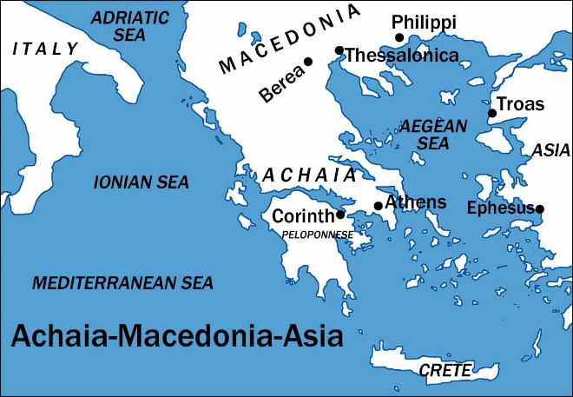
- Located on the Isthmus – narrow strip of land connecting the Peloponnesus to mainland Greece.
- Great Traffic in Corinth
  - Trade from east to west – either sail 200 miles around the cape of the peninsula, or travel across the Isthmus – about 5-6 miles.
  - Connected to mainland Greece – located on the Isthmus, people traveling from the Peloponnesus to Greece had to pass through Corinth.
- To korinthiazesthai – to Corinthianize – “to live like a Corinthian”
  - A term coined by the Greeks to describe Corinthian immorality.
  - Greek and Roman authors in the centuries before the rise of Christianity often referred to Corinth as the city of fornication and prostitution. (Hendriksen-Kistemaker)
  - The immorality within the city would obviously affect the church at Corinth. (See 1 Corinthians)
- Grecian Rhetoric and Love of Philosophy
  - The Corinthians were confusing the nature of the gospel as another philosophy. Paul had to eradicate such thought (cf. 1:12, 17; 2:1-5).
  - The Sophistic movement was popular – Sophist – “any orator who emphasized style over substance and received pay for his work” (Witherington 42).
    - Paul was criticized for his presence among the Corinthians (cf. 2 Corinthians 10:10; 1 Corinthians 2:1-5).
    - Paul’s authority was questioned as he did not receive wages from Corinth for his preaching (cf. 2 Corinthians 2:17; 11:5-11, 19-20; 12:13).
    - His meekness and humility was taken for weakness and a lack of authority by those who he called, “false apostles” (11:13).
    - He explained that the Apostolic authority was for the Corinthians’ benefit, and not for their destruction (cf. 10:7-8).
The Establishment of the church – Acts 18:1-17
- Established by Paul
  - Preached to Jews and converted some, but many rejected him. He then went to the gentiles (cf. 18:1, 4-8, 11).
  - In his letter he referred to his unique relationship with them (cf. 1 Corinthians 3:10; 4:14-15).
- A Daunting Task
  - Corinth was known for dishonesty, suspicion, speculation, egotism, debauchery and immorality. Paul’s task was great!
  - He recognized this (cf. 1 Corinthians 2:3). Some who did not like Paul held his presentation in contempt (cf. 2 Corinthians 10:10-11).
  - He feared for his life, but the Lord comforted him (cf. 18:9-10).
    - Jews tried to harm him, but God’s promise was kept (cf. 18:12-16).
The Purpose of the Letter
- Letter probably written only a few months after the first (maybe late 56 A.D.).
  - Left Ephesus to go to Macedonia (cf. Acts 20).
  - Spent some time in Troas (cf. 2 Corinthians 2:12-13).
- Met Titus in Macedonia and received news concerning the Corinthians’ response to the first letter (cf. 2 Corinthians 7:5-7).
- The second Corinthian letter is in response to the news brought by Titus. It was written shortly after Titus gave him the report.
  - Paul explained his motives for the sharp rebuke they received from him (cf. 2:3, 4, 9; 7:8).
  - Paul praises them for their positive response to the first letter – their repentance (cf. 7:8-12).
  - Despite the obvious positive remarks given to Paul by Titus in his report, it is evident by reading 2 Corinthians that not all was well:
    - He wants to get all his necessary rebukes out of the way before visiting them in person again (cf. 1:23-2:2; 13:10).
    - Some had not repented as others had (cf. 12:20-21).
    - Judaizing teachers/false apostles challenging Paul’s authority, and the Corinthians are being influenced by them:
      - Request of letters of recommendation (cf. 3:1-3).
      - They have closed themselves off from Paul (cf. 6:11-13; 7:2-4). This, even though he loved them dearly (cf. 1 Corinthians 4:14-16; 2 Corinthians 12:14-15).
      - Paul fears they will be corrupted by the false apostles (cf. 11:1-4).
- This letter includes praise and thanksgiving from Paul for the Corinthians’ positive response to his first letter. It also includes continued rebuke, and exhortation concerning things which still need correcting. Much of the letter contains Paul’s description of his ministry, and authority in Christ to combat the false teachers present among the Corinthians.

